 |  | 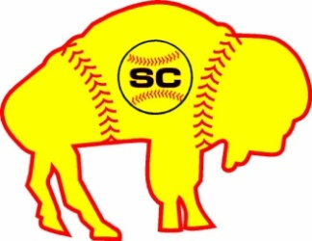 |  |  |  |  |  |  |  |  |  |  |  |  |  |  |  |  |  |  |  |  |  | 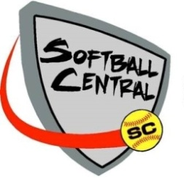
 |  |  |  |  |  |  |  |  |  |  |  |  | 1800 Broadway, Bldg C Buffalo, NY 14212 (716) 288 - 9455 www.softballcentral.org

RECRUITING PROGRAM COURSE OUTLINE

Week 1 Program Overview
Introduction to the program - parents welcome

Week 2 Plan to Succeed
Introduction and customization of profiles, timelines, and college spreadsheet

Week 3 Speaker - The Demands of a Student Athlete

Week 4 Exploration of Colleges, Divisions and Conferences
Introduce tools for research, PowerPoint of different divisions and conferences

Week 5 Check of Documents and Review of Plans
Individual time for documents, plan coach contact, PowerPoint of how to reach a coach, sample letters/templates

Week 6 Speaker - Picking a College

Week 7 Major/Career Exploration
PowerPoint and exercises on different majors and careers

Week 8 Refined College Look
Narrowing down colleges and personalized time for look at college lists

Week 9 Speaker - Life After College

Week 10 Check on Documents and Review of Plans
Personalized time to look at hurdles in the recruiting process and finalize profiles and documents

Week 11 AP Credits and Academic Steps
Resources to take advantage of academically and academic focus for college

Week 12 Speaker - Seizing Academic Opportunities

Week 13 Resume Writing and Career Building
How to write a resume and cover letter - where athletes should be based on age

Week 14 Plans for School Season
Recruiting, physical and academic plan for high school season

Week 15 Final Check and Review of Course
Wrap up and final questions - parents welcome

